**Acknowledgements**

I take this opportunity to express my profound gratitude and deep regards to my guide,  
***Prof. Rashma B.M, Assistant Professor, Dept of ISE***, for her exemplary guidance, monitoring and constant encouragement throughout the course of this technical seminar report.

The satisfaction that accompanies the successful completion of this semester would be complete only with the mention of people who made it possible. I would like to thank ***Dr. Suryaprasad J,*** ***Director and Principal, PESIT- Bangalore South Campus,*** for laying the foundation of this curriculum for us.

I would also like to thank ***Dr. Annapurna D, HOD, Dept of ISE,*** for projecting her ideas and providing the right path to a better future by fulfilling all my academic requirements.

I also take this opportunity to express a deep sense of gratitude to my seminar co-ordinators, ***Prof. Karthik.S, Associate Professor, Dept of ISE, and Prof. Sharmila Banu A, Assistant*** ***Professor, Dept of ISE,*** for their cordial support, valuable information and guidance which helped me in completing this task through various stages.

The help and guidance given by all of them from time to time shall carry me a long way in the professional journey that I am about to embark and I am very thankful to all of them for giving me the right guidance throughout.

**PRATIBHA AGARWAL**

**1PE15IS076**  
  
**RISHITA SAHA**

**1PE15IS086**

**ABSTRACT**

This site is used to provide the information to all the people who love to travel and wants to explore the beauty of the nature. Being armed with the right information about the places to visit, the facilities available over there and the ways to reach there.

The main aim of this system is to bridge the gap between the people from all over the world who want to visit ‘One State Many Worlds’ i.e. southern India’s Land of Heritage and Coffee – Karnataka and the agents providing the facilities and the hotels available for the tourists.

The users will be provided a forum where he can exchange information with travel agents, tourist guides and hotel managers in a more quick, effective and inexpensive manner.

At the website, a person can register and enter his details. Also he/she can specify his dates of travel, budget, preferences, and other attributes. On the basis of details entered, he’ll be provided with list of hotels, places to visit, eateries etc in that area. This will help him to plan his trip in a more efficient and hassle-free manner.

It can provide detail knowledge of tourism in a specialized manner and also provide area wise, agent wise, hotel wise information.

By using our website user can reduce the wastage of fairs in finding each and every information about a place as it would provide centralized information of tourist places as well as help him strategically plan his travel.

**Table of Contents**

**Chapter 1**: Introduction

**Chapter 2**: Requirement Specification

**Chapter 3**: Design

3.1: Schema diagram

3.2: ER-Diagram

3.3: Data Flow Diagram

3.4: UML diagram

**Chapter 4**: Implementation

**Chapter 5**: Results

**Chapter 6**: Conclusions and Future Enhancement

**Chapter 1:  Introduction**

The Tours and Travel Management System is a web based application. The main purpose of “Tours and travels management system” is to provide a convenient way for a customer to look at the places he can visit, the availability of hotels for accommodation, recreational activities to do at a particular place. The objective of this project is to develop a system that automates the processes and activities of a travel agency. In this project, we will make an easier task of searching places and ways of commute within each city. In the present system a customer has to approach various agencies to find details of places and to find out about the place. This often requires a lot of time and effort. We provide approach skills to critically examine how a tourist visits and its ability to operate in an appropriate way when dealing with the consequences of tourism, locally, regionally, and nationally including visitor security and ecological influences. It is tedious for a customer to plan a particular journey and have it executed properly. The project ‘Tours and Travels Management System’ is developed to replace the currently existing system.

**Chapter 2: Requirement Specification**

**2.1 HARDWARE**

* Processor: inteli52.4GHz, 64 bit processor and above
* RAM: 8 GB
* Hard Disk: 50 GB

**2.2 SOFTWARE**

* Operating System : Windows 10
* Programming Language : Html, CSS, Bootstrap, PHP
* Database  : MYSQL
* Web Browser : Google chrome or Mozilla Firefox
* Web development Suite : XAMPP (Apache Tomcat)

**Chapter 3: Design**

**3.1 Schema Diagrams**

**City**

|  |  |
| --- | --- |
| Cid | Cname |

**Places**

|  |  |  |  |  |  |
| --- | --- | --- | --- | --- | --- |
| Cid | Pid | Pname | Timings | Phone | Entry_fee |

**Accommodation**

|  |  |  |  |  |  |  |  |
| --- | --- | --- | --- | --- | --- | --- | --- |
| Cid | Hid | Hname | Location | Check_in | Check_out | Phone | Fare |

**Eateries**

|  |  |  |  |  |
| --- | --- | --- | --- | --- |
| Cid | Eid | Ename | Working_hours | Cost_for_two |

**Buses**

|  |  |  |  |  |  |
| --- | --- | --- | --- | --- | --- |
| Cid | Rid | From | To | No_of_Services | Timings |

**Guide**

|  |  |  |  |
| --- | --- | --- | --- |
| Gid | Cid | Gname | Status |

**Appointed**

|  |  |  |  |  |  |
| --- | --- | --- | --- | --- | --- |
| Id | Gid | Gname | Status | Appoint_dat | Action |

**3.2 ER- Diagrams**

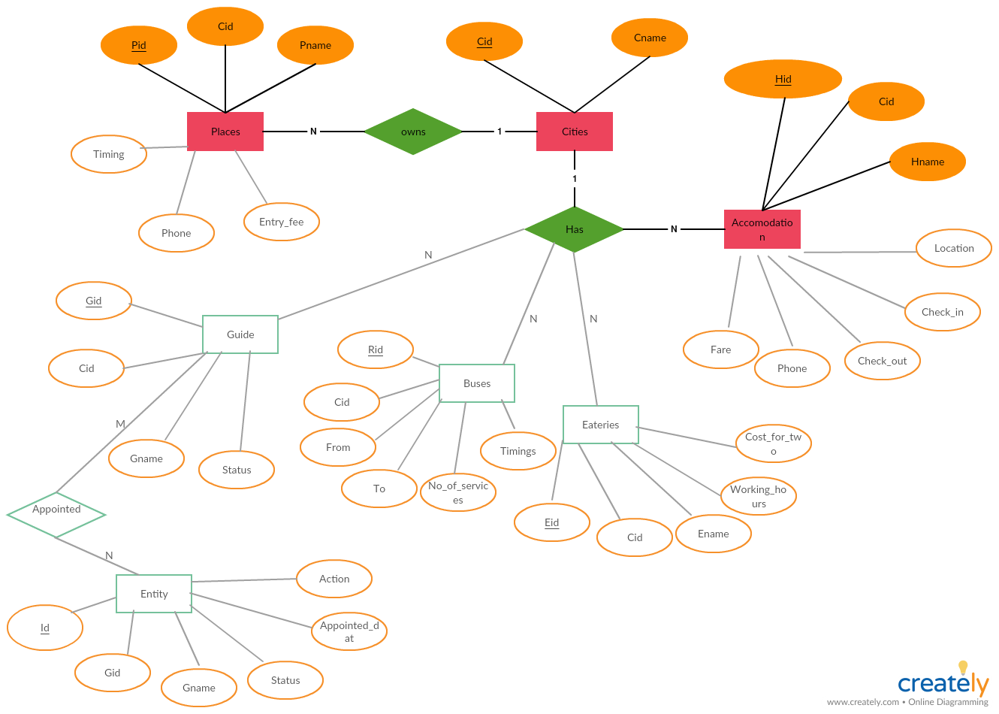

**Chapter 4: Implementation**

**6.1 User Interface Implementation**

HTML (The Hypertext Markup Language) and CSS (Cascading Style Sheets) are used for building web pages.HTML describes the structure of the web pages and CSS adds style to the web document. These web pages are deployed using the Xampp tool which contains Apache Tomcat server. These web pages serve as the user’s interface to access the database and perform various functions on it.

There are different tabs for various functions like viewing the cities, viewing the places, registration form for new users, feedback form. Additionally, there are tabs to add a new category or subcategory into the database, add a new city, register a new user and sign up a new user are also provided. These tabs take details through basic HTML forms. The data from all these forms is forwarded to a PHP File in which the PHP code processes them and accordingly updates the database to reflect the corresponding changes.

To make navigating from one page to another easy and have a bird’s view of the entire application, a navigation bar is provided with tabs for each of the functionality of the project. In addition to these HTML web pages, CSS is used alongside in order to enhance the appearance of the page in terms of color, alignment, table borders, navigation bar structure etc. The forms are in the form of HTML tables to ensure alignment.

**6.2 Database and Backend Implementation**

The database used for this application is MySQL database. SQL(Structured Query Language) commands are used to create, access and modify the database. The database is password protected and the PHP connectivity code must provide the right user and password while establishing connection in.

The data that is received as input through the HTML pages is received by a PHP file that is mentioned as the action to be taken on submitting the form. The PHP file has an established connection to the database where it does suitable operations on the database using the data as per the functionality selected by the user.

Connectivity to the database is obtained using the mysqli_connect(db_name,username,pwd). Connection and Statement objects are used to execute queries involving the access of the database. The result set is used to get output on execution of mysql queries.

This backend functionality is done in PHP Pages that receive data from the form input of the HTML pages of the user interface

**Chapter 5: Result**

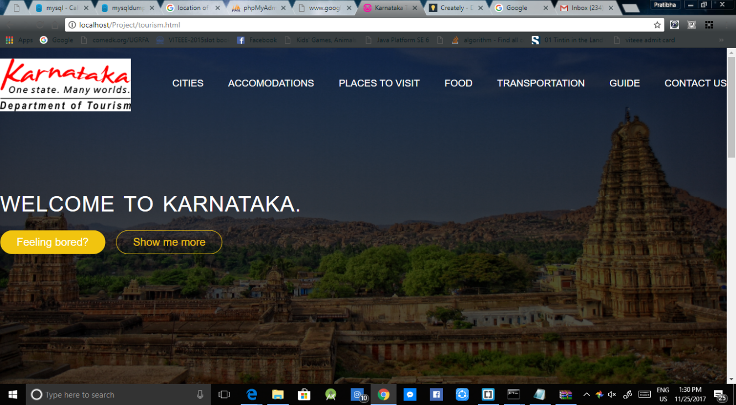

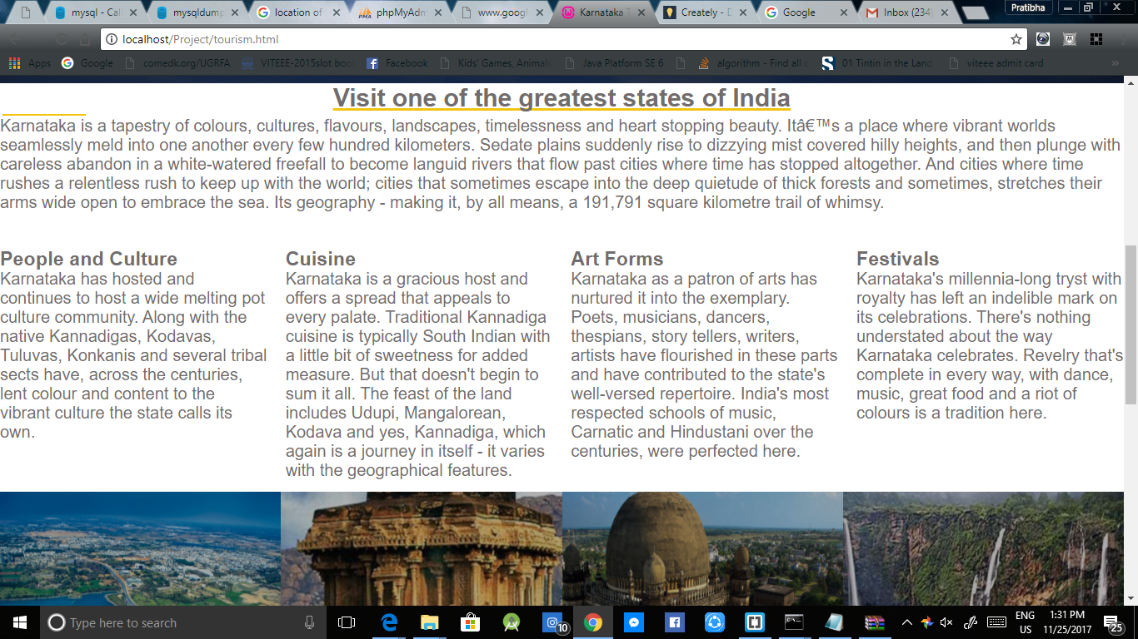

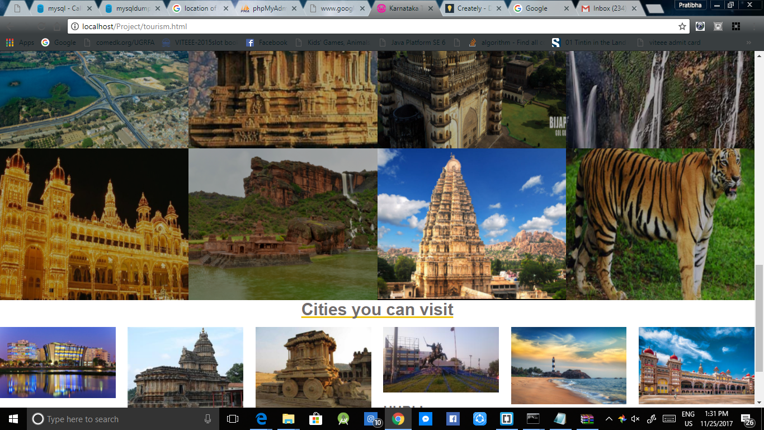

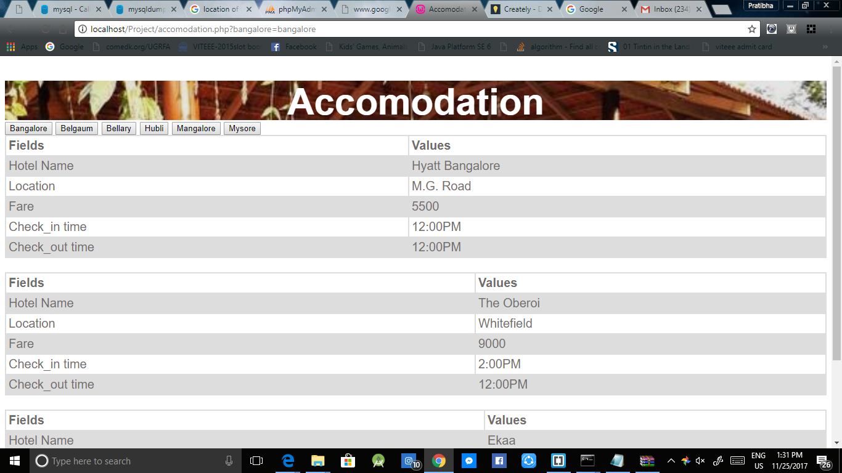

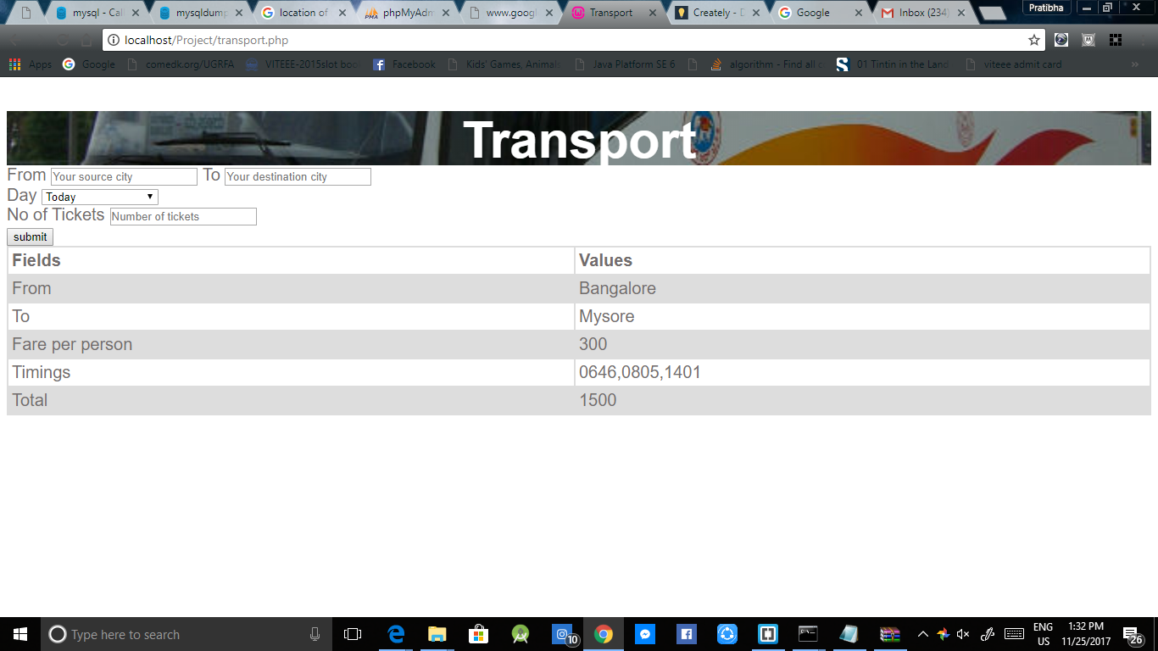

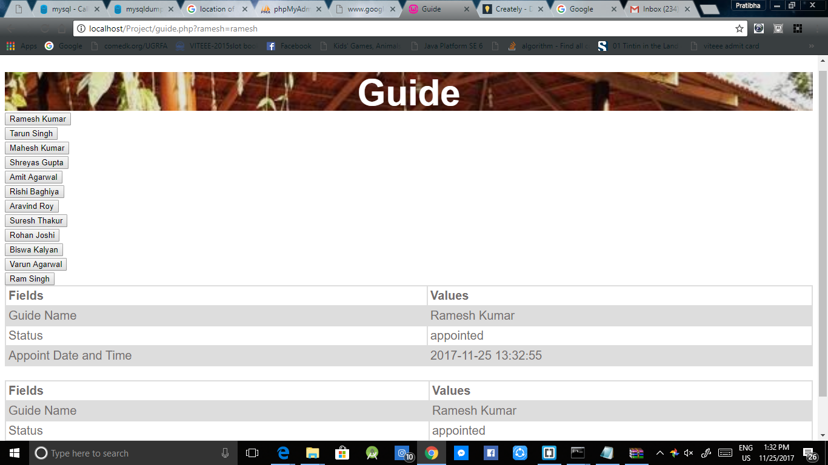

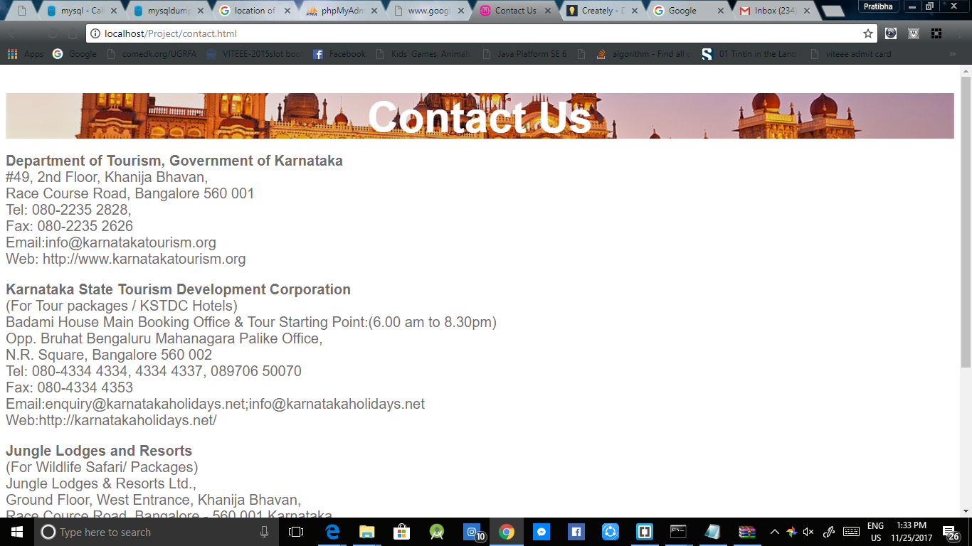

**Chapter 6: Conclusion**

The software development is never completed. There is always a need for modification. There could have been other approaches to implement the system. I have tried to my level best to make the system an interactive as possible.

The developed system is flexible and changes whenever can be made easy. Using the facilities and functionalities of PHP, the website has been developed in a neat and simple manner, thereby reducing the operators work. The speed and accuracy are maintained in proper way. The user friendly nature of this website developed in HTML and PHP is very easy to work with both for the admin as well as other users with little knowledge of computer.

This is a project with the objective to develop a basic website where a consumer is provided with a shopping cart application and also to know about the technologies used to develop such an application.

**References**

1. www.w3schools.com

2. www.tutorialspoint.com

3. www.freephpcode.com

4. www.phptpoint.com

5.Database systems Models, Ramez Elmasri and Shamkrant B.Navathe,7th Edition,2017,Pearson.